**Experiment1.2**

**Student Name**: Himanshu **UID**: 20BCS7944

**Branch**: CSE  **Section**: 905/A

**Semester**: 6 **Date of Performance**: 22/02/2023

**Subject Name**: Data Mining Lab **Subject Code**: 20CSP-376

**1) Aim:**

To perform the statistical analysis of data.

**2) Objective:**

To analyze the statistical data and perform various mathematical operations.

**3) Code and Output:**

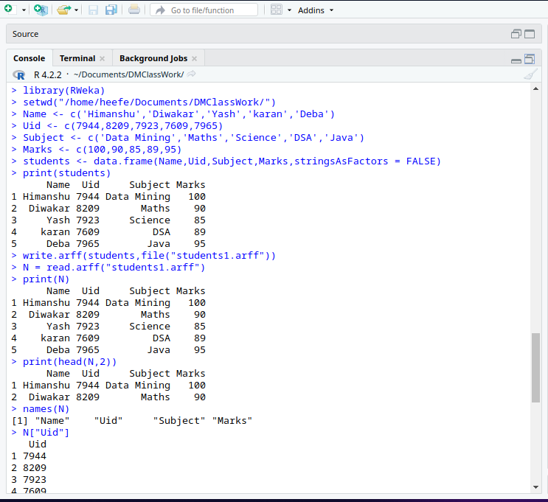

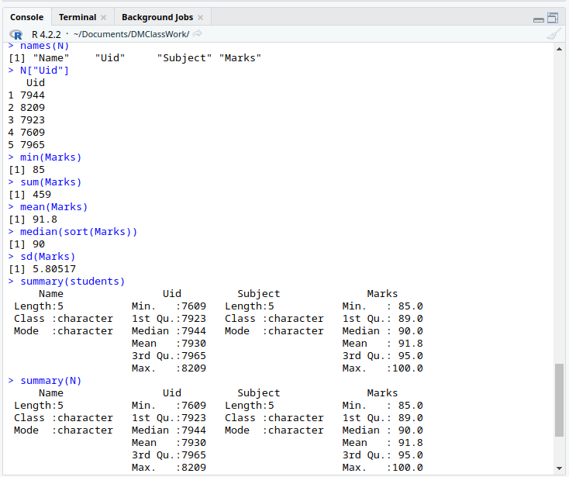

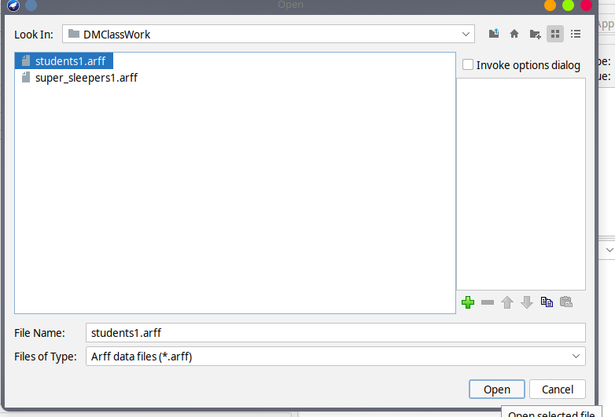

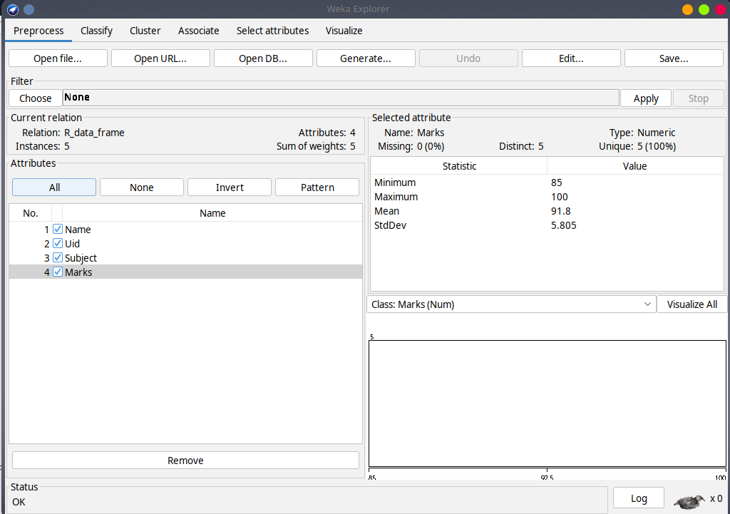

**Code -**

*library(RWeka)*

*setwd("/home/heefe/Documents/DMClassWork/")*

*Name <- c('Himanshu','Diwakar','Yash','karan','Deba')*

*Uid <- c(7944,8209,7923,7609,7965)*

*Subject <- c('Data Mining','Maths','Science','DSA','Java')*

*Marks <- c(100,90,85,89,95)*

*students <- data.frame(Name,Uid,Subject,Marks,stringsAsFactors = FALSE)*

*print(students)*

*write.arff(students,file("students1.arff"))*

*N = read.arff("students1.arff")*

*print(N)*

*names(N)*

*N["Uid"]*

*min(Marks)*

*sum(Marks)*

*mean(Marks)*

*median(sort(Marks))*

*sd(Marks)*

*summary(N)*